NVIDIA Evaluation and AI Breakthroughs Analysis
A Descriptive and Diagnostic Study of NVIDIA's Market Performance Across Three AI Eras (2010 to 2026)
Temporal alignment of price, earnings, and revenue mix with the AlexNet, Transformer, and ChatGPT milestones
Project Team
Member | Role
Pattanasavich Meenandhavech | Team Lead, Data Pipeline, Synthesis & Final Report
Agathiyan Akilan | Descriptive Analyst
Tony Nicholas Panneer Jesuraja | Diagnostic Analyst
Data window: 2010Q1 to 2026Q1. Non-causal: temporal alignment, not causation.

Contents
Contents 1
1. Introduction 1
2. Data and Methodology 1
2.1 Data sources 1
2.2 Era model and data-frequency rules 1
2.3 Descriptive methodology 1
2.4 Diagnostic methodology 1
3. Tools and Infrastructure 1
4. Findings 1
4.1 RQ1: Peer correlation and divergence 1
4.2 RQ2: Structural breaks in price, revenue, and net income 1
4.3 RQ3: Revenue mix, margins, and competitive share 1
4.4 RQ4: Structural growth versus gaming-era cyclicality 1
4.5 RQ5: Milestone timing and the demand backdrop 1
5. Conclusions 1

1. Introduction
Before 2017, NVIDIA was valued largely as a leader in the cyclical gaming and graphics market. The Transformer architecture (Attention Is All You Need, 2017) shifted the AI field toward large-scale training of language models, and ChatGPT (late 2022) served as a global proof-of-concept that triggered an unprecedented surge in demand for high-performance compute. Over the window studied, NVIDIA's split-adjusted quarter-end price rose roughly 1,100 percent (about 12 times), from $14.58 at the end of 2022Q4, the quarter ChatGPT launched, to $174.20 in 2026Q1, and roughly 411 times from the start of 2010.
Aim. This project asks whether NVIDIA's price, earnings, and revenue mix exhibit a structural change that aligns, in time, with three milestones in AI architecture: convolutional neural networks (AlexNet, 2012Q3), attention-based Transformers (2017Q3), and the generative-AI wave catalyzed by ChatGPT (2022Q4), and if so, which milestone the change lines up with most cleanly. NVIDIA is analyzed across three eras and compared against semiconductor peers (AMD, Intel) and market benchmarks (Nasdaq-100, PHLX Semiconductor Index).
Framing. This study is descriptive and diagnostic, not causal. It documents temporal alignment: where structural shifts in NVIDIA's series line up in time with AI milestones. It does not claim those milestones caused the shifts. Where the text uses language like “driven by” or “accompanied,” it should be read as association, not proof of causation. Isolating causation would require controls and counterfactuals outside this project's scope.
Research questions. The analysis is organized around five questions:
- RQ1. How has NVIDIA's return correlation with its peers (AMD and Intel) and the Nasdaq-100, along with its divergence in price and revenue, evolved as its revenue model shifted from gaming-centric to data-center-centric?
- RQ2. Do NVIDIA's split-adjusted price, revenue, and net income exhibit statistically detectable structural breaks, and where do those breaks fall relative to the three AI milestones?
- RQ3. How did NVIDIA's revenue mix (Gaming to Data Center), margin structure, and share of the combined NVDA/AMD/Intel revenue pool shift across the three eras?
- RQ4. How does NVIDIA's price and earnings trajectory after the 2017 architectural shift compare with its earlier gaming-era cyclicality?
- RQ5. How does the timing of the AI milestones line up with changes in NVIDIA's revenue, revenue mix, and margins, and with the hyperscaler capital-expenditure backdrop?

2. Data and Methodology

2.1 Data sources
Three independent sources produce five analysis-ready datasets, all covering 2010 to 2026, which feed a single unified quarterly panel that every analysis reads from.
Source | What it provides | Datasets
SEC EDGAR (XBRL company-facts API) | Quarterly fundamentals (revenue, gross/operating/net income, diluted EPS & shares) for NVDA, AMD, INTC; capital expenditure for the hyperscalers (MSFT, GOOGL, AMZN, META) | sec_fundamentals_wide / _long.csv
Yahoo Finance (yfinance) | Split/dividend-adjusted daily prices and quarter-end series for NVDA, AMD, INTC and the ^NDX / ^SOX indices | yahoo_prices_daily / _quarterly.csv
NVIDIA 10-K filings (hand-collected) | Annual revenue by reportable segment (Gaming, Data Center, Pro Visualization, OEM & Other), FY2013 to FY2025 | nvda_segments_annual.csv

The sources are unified at a join step into master_quarterly_panel.csv, keyed on calendar quarter, with trailing-twelve-month and year-over-year series derived and provenance carried for every value. An audit artifact, sec_completeness_report.csv, records coverage and gaps per company and metric. All generated CSVs are committed, so the analysis reproduces without re-running the pipeline.

2.2 Era model and data-frequency rules
NVIDIA is partitioned into three eras: Pre-Attention / CNN (2010Q1 to 2017Q2), Transformer (2017Q3 to 2022Q3), and Generative-AI (2022Q4 to 2026Q1), with the AlexNet milestone (2012Q3) annotated inside the first band. NVIDIA's fiscal year ends in late January, so fiscal year n corresponds to roughly calendar year n minus 1 (for example, FY2023 is roughly calendar 2022). This mapping is applied consistently so segment data aligns with the price and earnings timeline.
Data frequency is treated as a deliberate rule: prices and returns are used at daily native resolution, fundamentals at quarterly resolution, and segments at annual resolution, rather than forcing all series onto a single grid.

2.3 Descriptive methodology
The descriptive analysis documents what happened across six analytical pillars (structural trajectory, peer divergence, revenue mix, margin expansion, competitive share and return co-movement, and capex linkage) in eleven charts generated reproducibly from the panel. Conventions include trailing-twelve-month smoothing for level series, log scales to read rate rather than magnitude, mirrored same-scale axes rather than independent dual axes (which can manufacture visual alignment), and era-aggregated grouped bars where per-quarter bars would be too cluttered to interpret.

2.4 Diagnostic methodology
Structural-break detection. Two complementary tests date regime changes in NVIDIA's series. Bai-Perron is a global dynamic-programming search for an unknown number of breaks at unknown dates, with the break count selected by BIC and cross-checked by sequential sup-F tests. Quandt-Andrews is a sup-Wald test for a single unknown break, reporting the dominant inflection. Both use 15 percent symmetric trimming and wild-bootstrap p-values, with bootstrapped break-date confidence intervals. Series are transformed according to their statistical character: price as log level (a trend-break model, so a break is a change in the growth trajectory); revenue and net income as year-over-year log growth (a mean-break model, deseasonalized and stationarized), with the single 2010Q2 net-income loss excluded so the log is defined.
Return co-movement. Decoupling is measured on daily log returns two ways. A clean per-era Pearson correlation (computed once per era, no window overlap) carries the ranking of NVIDIA against Intel, AMD, and the Nasdaq-100. A 126-day rolling correlation, Fisher-z transformed and sampled monthly, is then break-tested (mean-shift Bai-Perron and Quandt-Andrews, 20 percent trimming) with moving-block-bootstrap p-values to respect window overlap, in order to date when any decoupling occurs.
Non-causal stance and data-quality notes. All tests date and rank; none identify cause. Correlation in particular is symmetric, so a decoupling cannot distinguish NVIDIA pulling away from a peer's own decline. Two data-quality limits are carried explicitly: NVIDIA's early segment years include a sizeable unallocated band, and at least one Data-Center figure (around FY2016/FY2017) is a flagged transcription duplicate, so segment-derived results are treated as directionally indicative only and are not relied upon elsewhere. Hyperscaler coverage is capital-expenditure only.

3. Tools and Infrastructure
Language and libraries. The project is built in Python 3.10+ (tested on 3.12), using pandas and NumPy for data handling, Matplotlib for figures, and Jupyter notebooks executed and validated end-to-end with nbconvert. Dependencies are pinned in requirements.txt (version floors) and requirements.lock (exact versions).
Pipeline architecture. A reusable engine in Source/ separates ingestion from analysis. Four ingestion scripts run in dependency order through an orchestrator (run_pipeline.py): sec_edgar_ingest.py (SEC fundamentals and hyperscaler capex, with on-disk caching, XBRL tag reconciliation, and derived Q4 figures), yahoo_prices_ingest.py (adjusted daily prices and indices, resampled to quarter-ends), segments_ingest.py (NVIDIA segment revenue, recomputing shares from raw dollars), and join_quarterly.py (the unified panel). A shared common.py module is the single source of truth for the era definitions, milestone and confounder markers, the fixed per-ticker color palette, the data loaders, and the Matplotlib annotation helpers, so every chart renders eras and milestones identically.
Data access. SEC EDGAR is accessed through its XBRL company-facts API under a configurable User-Agent (SEC_IDENTITY) per SEC's fair-access policy; Yahoo Finance is accessed with yfinance. Each ingestion stage runs standalone and ships an offline self-test against synthetic fixtures, and all stages log to Logs/ through a shared logging configuration.
Reproducibility and version control. The project offers two reproduction paths: working directly from the committed datasets (no network), or rebuilding everything from source with the pipeline. The work is version-controlled on GitHub, organized into the reusable engine (Source/), a single data source of truth (Data/), the two analysis folders (each with its notebook, figures/, and findings/), documentation, logs, and an archive of superseded material. Notebook outputs are committed so results render without re-execution.

4. Findings
This section reports findings against the five research questions, drawing on the eleven descriptive charts (Figures 01 to 11) and the diagnostic results (Figures 12 to 17). Consistent with the study's framing, every finding describes temporal alignment between NVIDIA's series and the three AI milestones and does not assert causation.

4.1 RQ1: Peer correlation and divergence
Price and revenue divergence (descriptive). Indexed to a 2010 base (Figure 05), the five series move within a common band for most of the first decade before NVIDIA separates decisively, the gap widening through the Generative-AI era. Revenue divergence (Figure 07) records the concrete crossover: NVIDIA's trailing revenue passes Intel's for the first time at 2023Q4, after a decade below it.
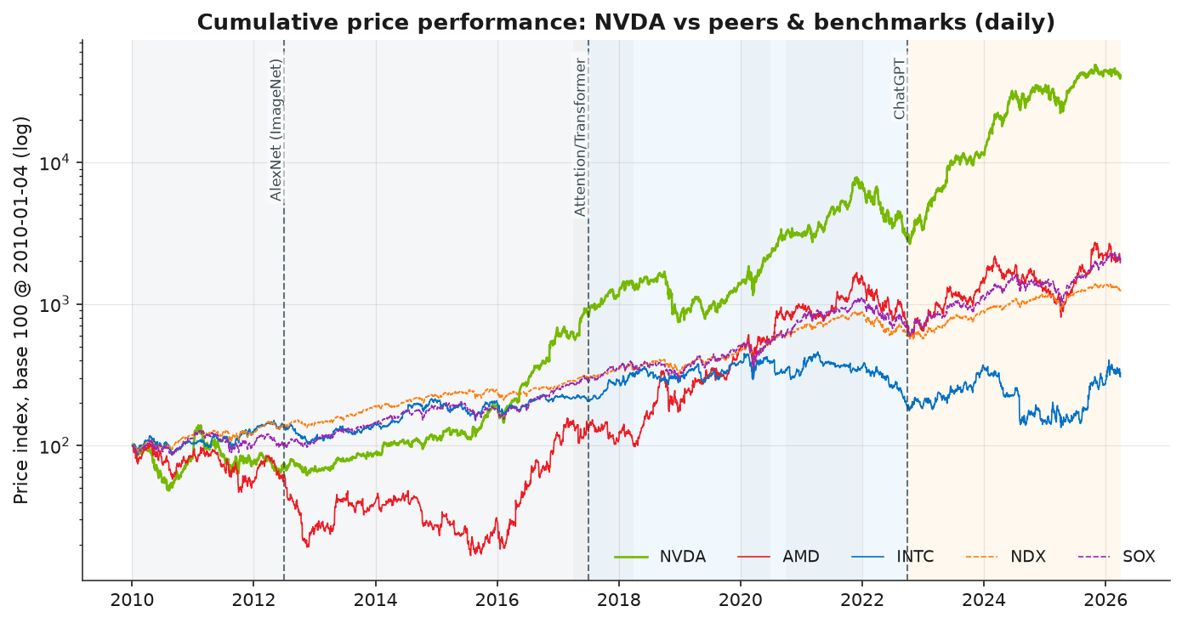
Figure 05. Peer price index (base 100, log scale): NVIDIA separates and pulls ahead.
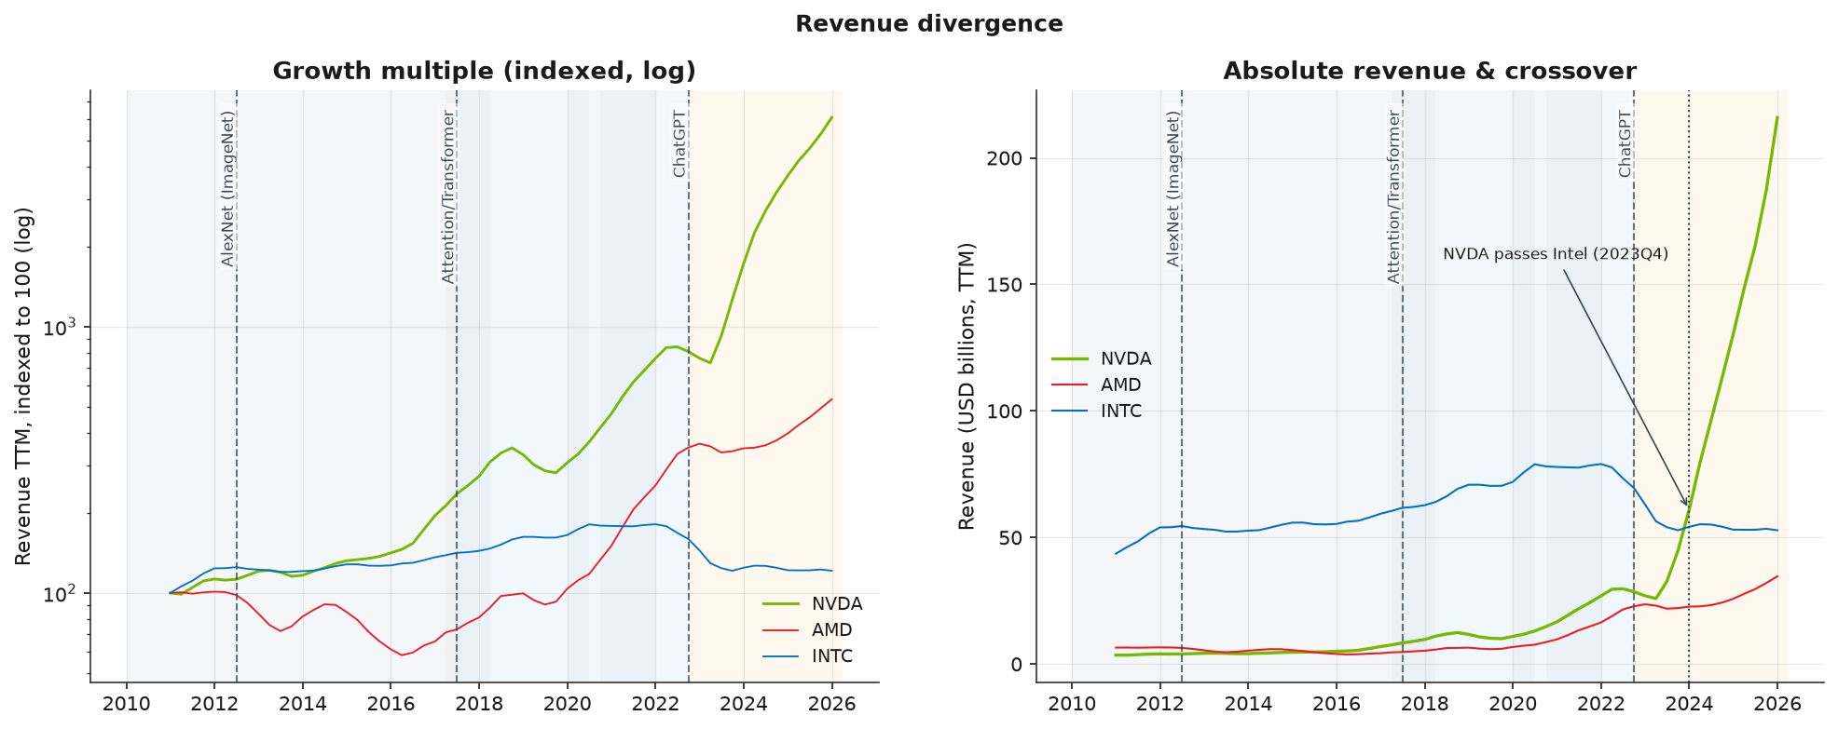
Figure 07. Revenue divergence: NVIDIA's trailing revenue passes Intel's at 2023Q4.
Return co-movement (descriptive and diagnostic). A single per-era correlation (Figure 08) already shows NVIDIA's correlation with Intel falling while its correlation with the Nasdaq-100 stays high. The diagnostic pillar refines this: computed once per era on daily log returns, NVIDIA's correlation in the Generative-AI era is ordered INTC 0.32 < AMD 0.63 < NDX 0.76 (Figure 17), so NVIDIA decouples most from Intel and least from the Nasdaq-100, with AMD intermediate. The Transformer-to-Generative-AI change is ranked identically (INTC minus 0.27, AMD minus 0.08, NDX minus 0.05). Dating the 126-day rolling correlation (Figures 15 and 16) places the Intel decoupling at the generative-AI onset (about 2023Q1), while AMD's and the Nasdaq-100's dominant co-movement shifts fall earlier (2019 and 2018).
Era | NVDA-INTC | NVDA-AMD | NVDA-NDX
Pre-Attention / CNN | 0.46 | 0.43 | 0.58
Transformer | 0.59 | 0.71 | 0.81
Generative-AI | 0.32 | 0.63 | 0.76

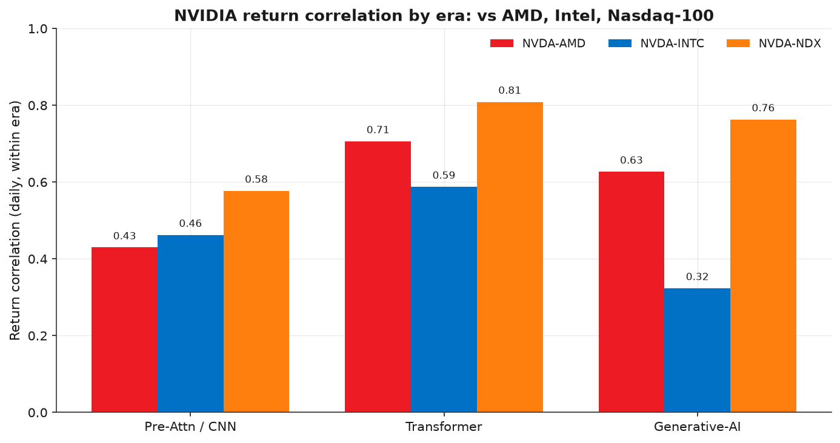
Figure 08. Return correlation by era (descriptive): NVIDIA decouples from Intel, tracks the market.

Figure 17. Return correlation by era (diagnostic): the generative-AI ranking INTC < AMD < NDX.
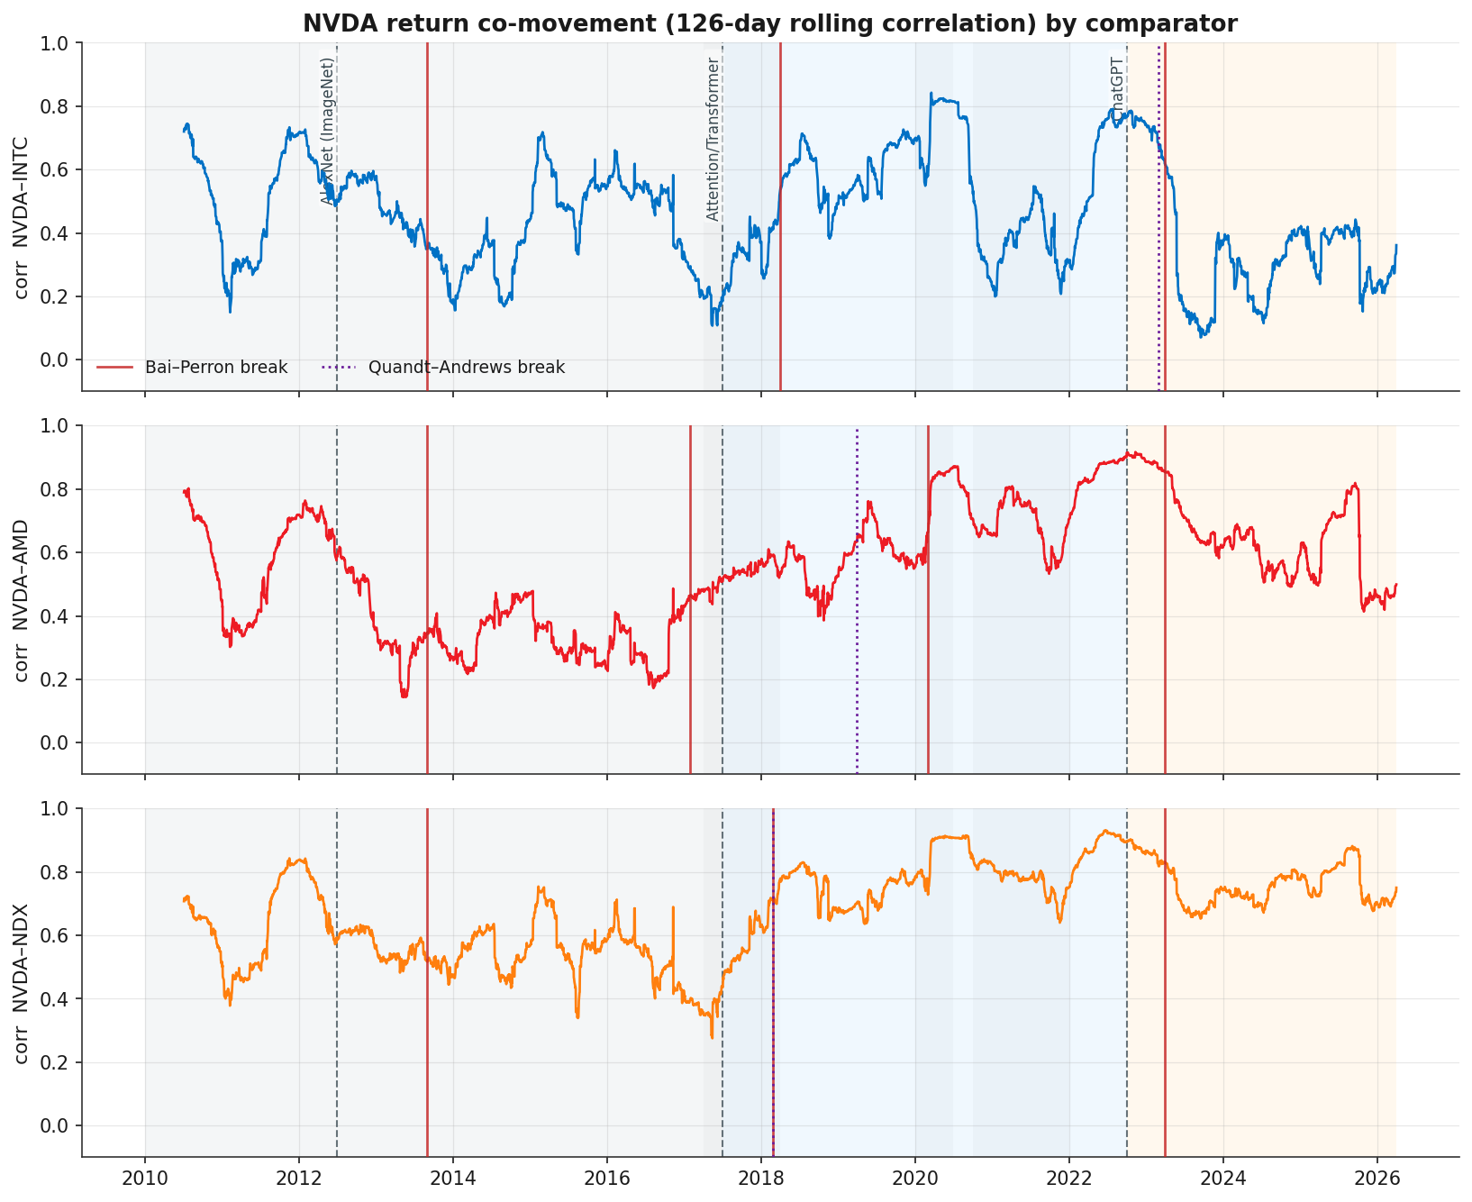
Figure 15. Rolling 126-day correlation by comparator, with structural breaks: the Intel collapse dates to gen-AI.
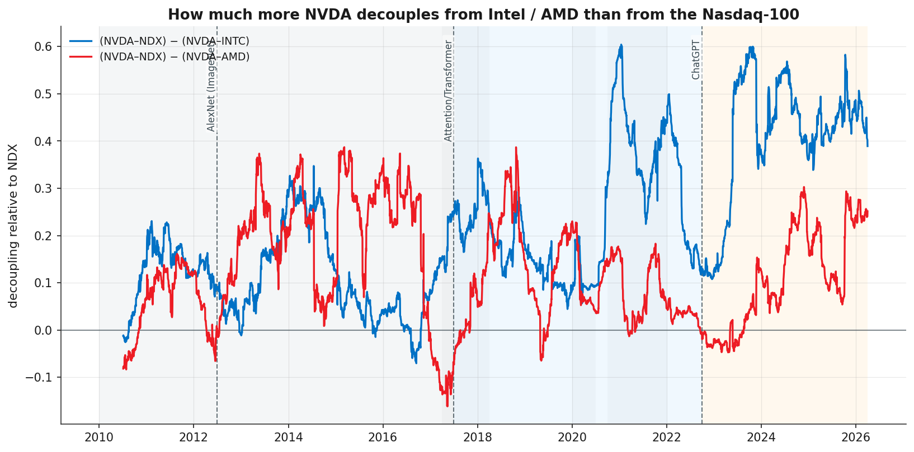
Figure 16. Decoupling relative to the Nasdaq-100: NVIDIA decouples from Intel more than from AMD post-ChatGPT.
Reading. This evidences that NVIDIA's return behavior became distinct, most sharply from Intel and timed to gen-AI. It is read as distinctiveness, not causation: the same decoupling is equally consistent with Intel's own decline, and a symmetric correlation cannot separate the two. NVIDIA's large and growing weight in the Nasdaq-100 also mechanically supports that index as the least-decoupled anchor.

4.2 RQ2: Structural breaks in price, revenue, and net income
The descriptive price and revenue/net-income series (Figures 01 and 02) supply the inputs; the formal tests are diagnostic, run with Bai-Perron and Quandt-Andrews.
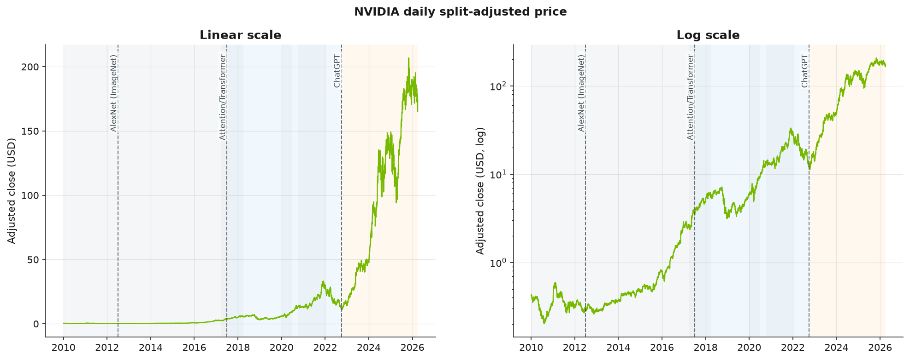
Figure 01. NVIDIA price on linear and log scales: a sustained multi-year climb, not a single late spike.
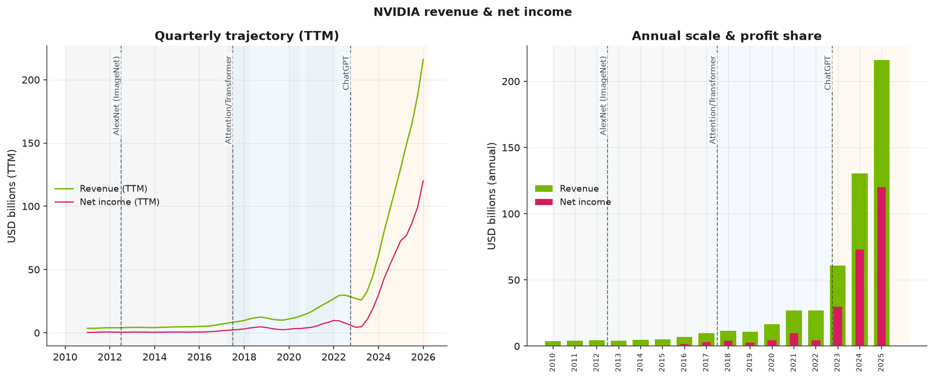
Figure 02. NVIDIA revenue and net income: slow growth, then acceleration into the generative-AI era.
Fundamentals break once, at the generative-AI onset. NVIDIA's year-over-year revenue growth and net-income growth each contain exactly one structural break, both dated 2023Q2, and the result is double-corroborated: the two tests agree to the quarter, with confidence intervals straddling the ChatGPT marker (Figures 13 and 14). This is the cleanest, most robust alignment in the study.
Price re-rates earlier, and not on the milestones. The log-price trend contains three breaks (2015Q1, 2018Q4, 2022Q2; dominant single break 2015Q4): the re-rating begins in 2015, before the Transformer and generative-AI markers, and the later two breaks fall on the late-2018 crypto/market correction and the 2022 rate-hike sell-off rather than on any milestone (Figure 12). NVIDIA's generative-AI alignment is therefore a fundamentals phenomenon, not a price one.
Series | Structural breaks | Tests | Nearest milestone
log(price) | 2015Q1, 2018Q4, 2022Q2 | dominant 2015Q4 | none (precedes / confounders)
YoY revenue growth | 2023Q2 | BP & QA agree | ChatGPT (2022Q4)
YoY net-income growth | 2023Q2 | BP & QA agree | ChatGPT (2022Q4)

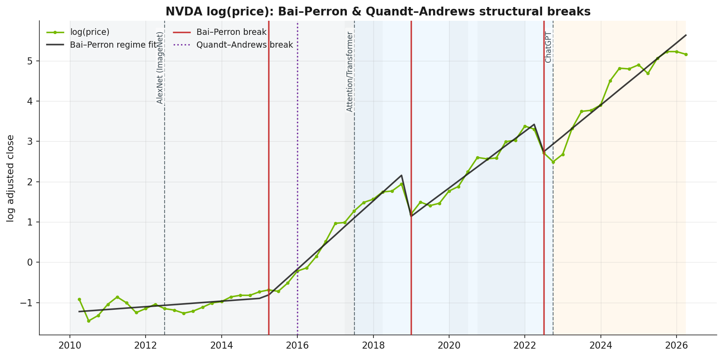
Figure 12. NVIDIA log(price): Bai-Perron and Quandt-Andrews structural breaks.
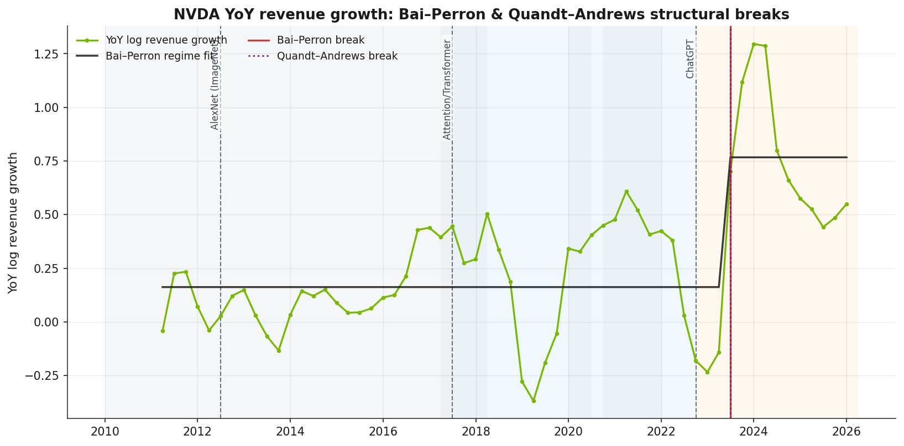
Figure 13. NVIDIA YoY revenue growth: a single break at 2023Q2, at the generative-AI onset.
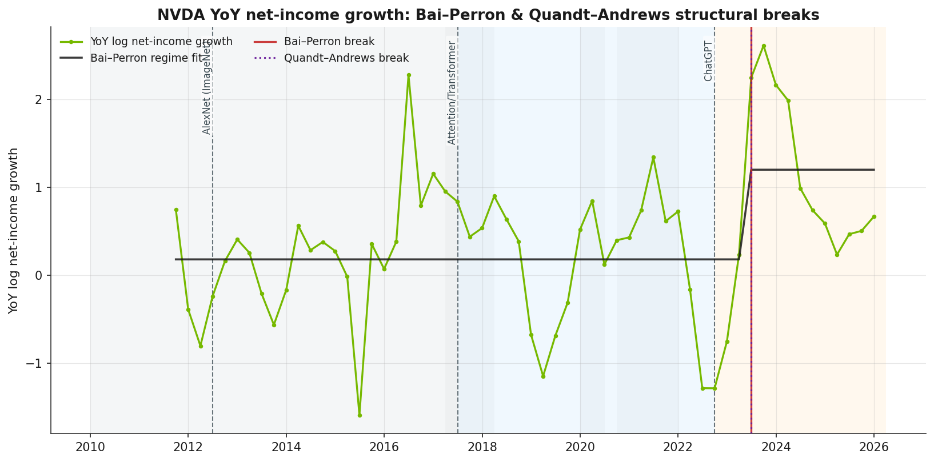
Figure 14. NVIDIA YoY net-income growth: a single break at 2023Q2, corroborating revenue.

4.3 RQ3: Revenue mix, margins, and competitive share
Margins (panel-based, robust). Net-income share rises from roughly 7 percent in 2010 to about 56 percent in 2025 (Figure 04). Aggregated by era, NVIDIA's gross margin moves 54 to 61 to 72 percent, while Intel falls 62 to 56 to 36 percent and AMD rises 35 to 45 to 48 percent (Figure 09): the margin leader of the Pre-Attention era is the laggard by the Generative-AI era.
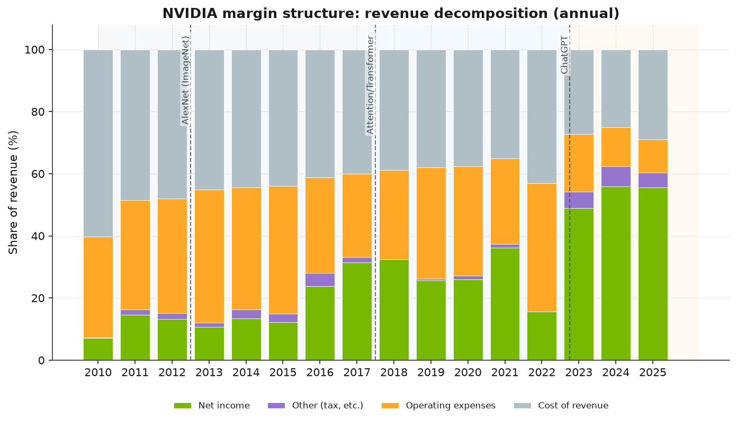
Figure 04. NVIDIA margin structure: net-income share rises from about 7 to 56 percent.
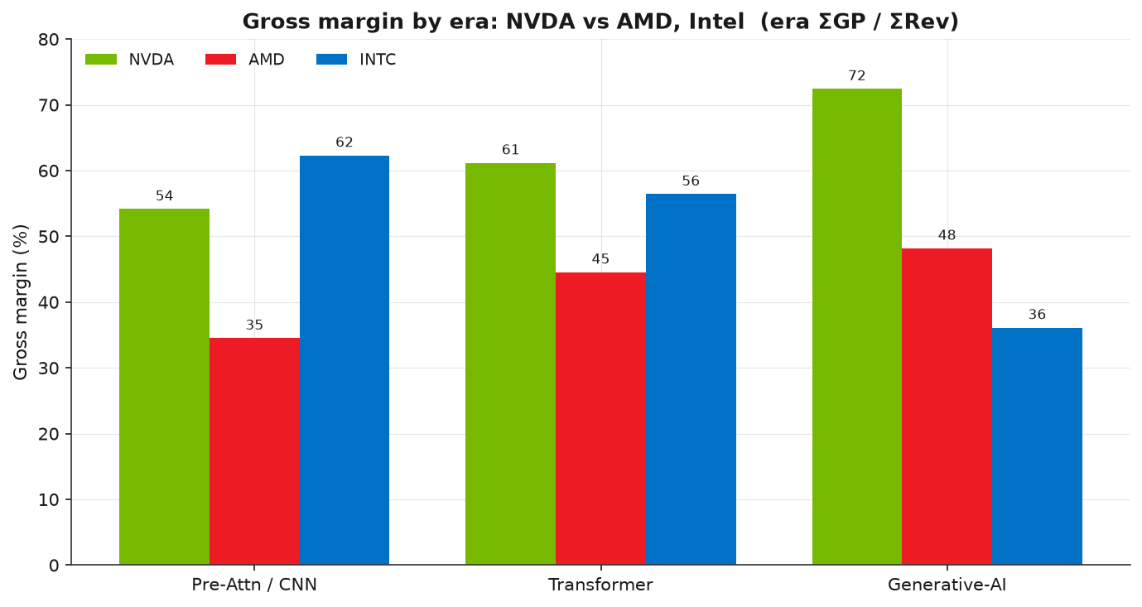
Figure 09. Gross margin by era: NVIDIA rises, Intel falls, a leadership reversal.
Competitive share (panel-based, robust). Among the three firms, revenue share reverses almost completely: Intel 84 to 71 to 26 percent, NVIDIA 8 to 17 to 61 percent, AMD 8 to 11 to 13 percent, concentrated in the Generative-AI band (Figure 10). This is share of these firms' combined revenue, not product-market share; the early 84 percent mainly reflects Intel being a far larger company.
Metric | Pre-Attention | Transformer | Generative-AI
NVDA gross margin | 54% | 61% | 72%
Intel gross margin | 62% | 56% | 36%
AMD gross margin | 35% | 45% | 48%
NVDA revenue share | 8% | 17% | 61%
Intel revenue share | 84% | 71% | 26%
AMD revenue share | 8% | 11% | 13%

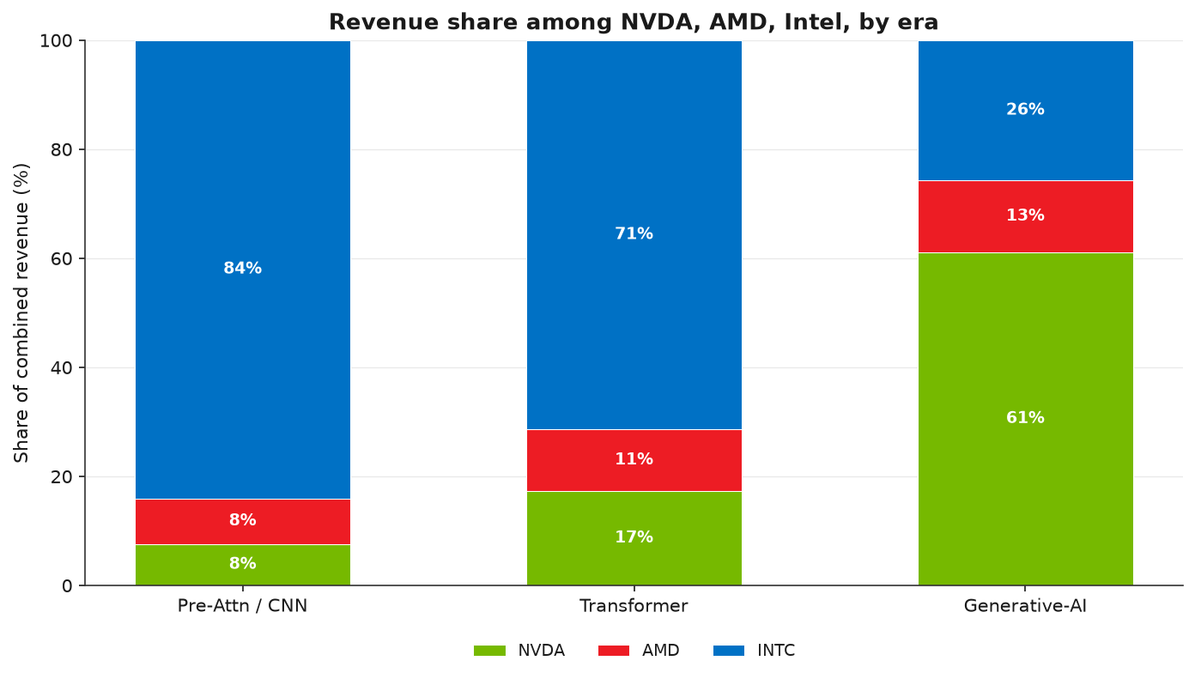
Figure 10. Revenue share of the three-firm pool by era: a near-total reversal in the gen-AI band.
Revenue mix (segment-based, data-quality caveat). The internal mix (Figure 03) shows Data Center overtaking Gaming in calendar 2022, NVIDIA's fiscal 2023, aligning with the ChatGPT marker. This is reported with a caveat: the segment series is annual and hand-collected, the early years carry a sizeable unallocated band, and at least one Data-Center figure (around FY2016/FY2017) is a flagged transcription duplicate. The crossover is therefore directionally indicative only; the segment figures are not relied on for precise dating, and no segment-derived claim is given weight elsewhere.
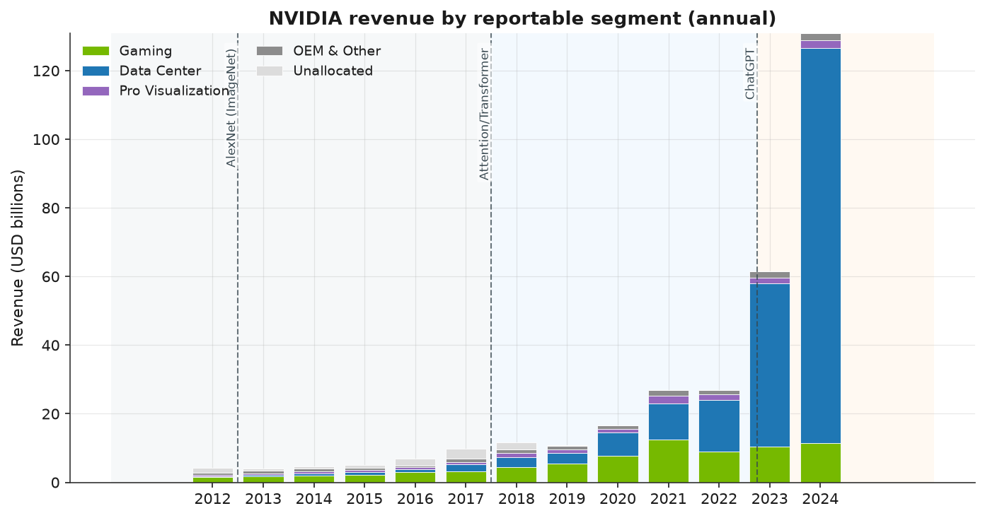
Figure 03. NVIDIA revenue by segment: Data Center overtakes Gaming in calendar 2022 (segment data caveated).

4.4 RQ4: Structural growth versus gaming-era cyclicality
On a log scale, NVIDIA's price (Figure 01) is a sustained multi-year climb that begins lifting in the mid-2010s and steepens through each successive era, rather than a single late spike; relative strength (Figure 06) confirms genuine outperformance beginning around 2016. The structural-break tests substantiate a regime change rather than amplified cyclicality: the price moves through distinct trend regimes (three breaks), and the fundamentals shift once into a higher growth regime at 2023Q2. The log-price steepening aligns with the Transformer marker as well as with gen-AI, indicating the acceleration is not purely a 2022 event. Set against the flat, cyclical gaming era before 2017, the post-2017 trajectory is one of sustained structural growth across price, revenue, and margins.
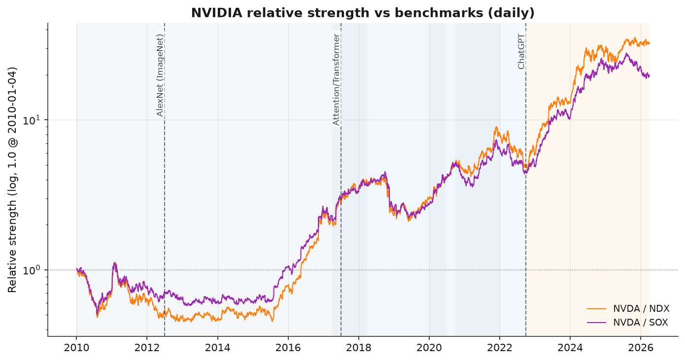
Figure 06. Relative strength versus benchmarks: outperformance begins around 2016, before ChatGPT.

4.5 RQ5: Milestone timing and the demand backdrop
The cleanest temporal alignments cluster at the generative-AI onset: the revenue and net-income structural breaks (2023Q2), the Intel return-decoupling (about 2023Q1), and the upturn in NVIDIA's capture of hyperscaler capital expenditure. The capex linkage (Figure 11) traces a U-shaped capture rate, about 47 percent in 2011, down to roughly 15 percent around 2019 to 2020, and back to about 57 percent by 2025, with the upturn aligning with the ChatGPT marker as GPUs became central to cloud build-outs. The segment crossover (Figure 03, caveated above) maps to the same window. Earlier milestones align with earlier signals: the price re-rating onset and the relative-strength crossover (about 2015 to 2016) sit between the AlexNet and Transformer markers.
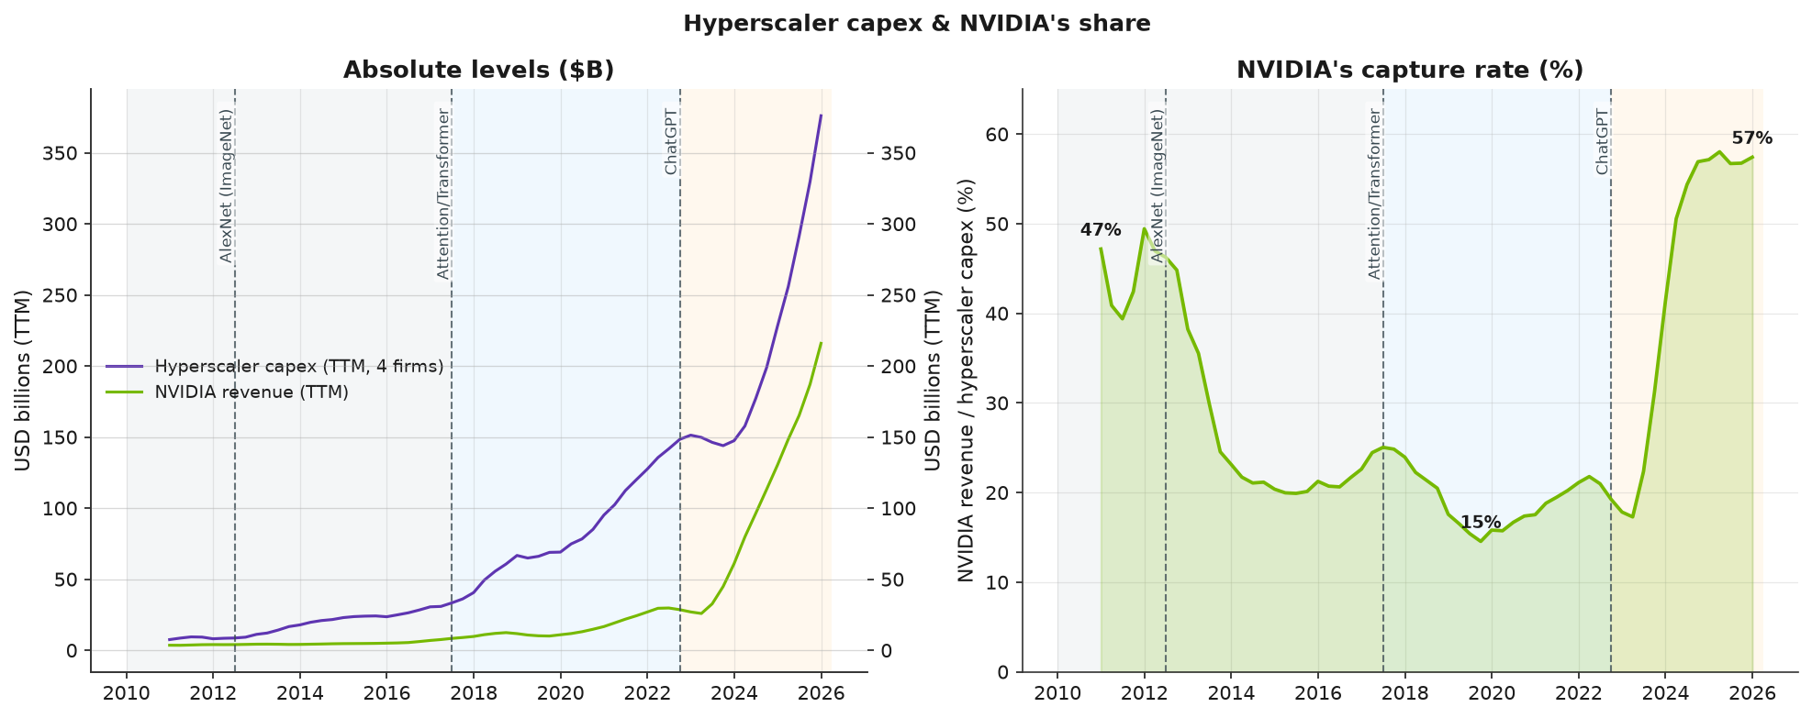
Figure 11. Hyperscaler capex versus NVIDIA revenue, and the capture rate: the upturn aligns with ChatGPT.

5. Conclusions
Across the five research questions a consistent pattern emerges: NVIDIA's series inflect convergently in the Generative-AI era, but the strength of the temporal alignment differs sharply by series, and only some of it survives formal testing and data-quality scrutiny.
What aligns most cleanly. The single most robust result is in the fundamentals: NVIDIA's revenue and net-income growth each break exactly once, at 2023Q2, with two methodologically different tests agreeing to the quarter and their confidence intervals straddling the ChatGPT marker. The competitive repositioning is equally clear, with the margin and revenue-share orderings reversing in the same era, and NVIDIA's return behavior decoupling in the Generative-AI era ranked exactly as hypothesized (most from Intel, least from the Nasdaq-100), the Intel decoupling dated to the same onset. To the extent the study identifies a milestone the changes line up with most cleanly, it is the generative-AI / ChatGPT inflection for NVIDIA's fundamentals and competitive position.
What aligns earlier, or only weakly. NVIDIA's price tells a different story from its fundamentals: the price re-rating and market outperformance begin in 2015 to 2016, before the Transformer and generative-AI markers, and the later price breaks coincide with crypto and macro events rather than AI milestones. The revenue-mix evidence, though directionally consistent with the gen-AI timing, rests on a segment series with a known data-quality flaw and is therefore not relied upon. The result is a layered picture: the market re-rated NVIDIA well before its fundamentals inflected at gen-AI.
Limitations. The diagnostic work analyzes a single firm with no control or counterfactual; the quarterly samples are modest (about 58 to 65 observations), giving limited statistical power and wide break-date confidence intervals; the co-movement evidence is symmetric and cannot separate NVIDIA's ascent from a peer's decline; and the segment data quality constrains the revenue-mix conclusions. Most fundamentally, every result is a statement of temporal alignment. Isolating causation, establishing that the AI milestones caused NVIDIA's structural changes rather than merely coinciding with them, would require controlling for the concurrent crypto, COVID, and macro confounders and constructing a valid counterfactual, both beyond this study's scope.
Closing. Within those bounds, the evidence is consistent with NVIDIA's trajectory being tied to the AI-architecture transitions, most cleanly and most defensibly at the generative-AI inflection in its fundamentals and competitive position, and earlier and more loosely in its market price.

